Earliest Years

Randall McMullan was born in Wellington, New Zealand. A Capital City of no great heat, but a city of light, and a city of sounding winds. The Evening Post newspaper of Wellington printed a notice of his birth, on the very same day of his birth, 6 September 1944, confirming his mother’s memory of the birth being early in the day at 1230 am. The place was the private Harris Hospital, Ghuznee Street; a large converted 2-storied house now lost to the motorway tunnel.

In December 1936 the Evening Post carried the following notice:
McMULLAN—RANDALL. The engagement is announced of Agnes Adelaide, second daughter of Mr. and Mrs. L. V. Randall, Wellington, to Laurence Gerard, younger son of Mr. and Mrs. T. McMullan, Dunedin.

Randall’s parents were married in 1939 after a long courtship and then still took their time to produce Randall in 1944, followed by his sister Lyndsay in 1947.

***

My early memories of the physical world are linked to the flat that we lived in at 11 Rankin Street, Wadestown and to the house-shop of my grandparents (Lou and Maggie Randall) at 342 Tinakori Road, Thorndon. The Tinakori Road residence had the added physical interest of an attached dairy shop full of things and people, a range glowing in the kitchen, a large RCA radio in the lounge, and stairs upwards to the 3 bedrooms and bathroom. The raised patch of garden and lawn at the back of the house is the scene for many photos of various family members with me.

My father was a conscript in the army at the time of my birth and he was overseas, out of my life, from when I was 5 months old until I was 18 months. There is a quayside photo of Larry in uniform, just stepped off the troopship, holding me; I am looking not altogether sure about this stranger. Meanwhile my mother obviously spent much of her time at Tinakori Road with her parents and other family members. I well remember the floor layout of both places, acquired as a result of crawling and toddling. I also recall standing on the seat of a tram looking out the window as the tram laboured up through ‘the cutting’ of Lennel St to our Wadestown tram stop at Pitt St.

Another memory was of hot sand at the beach burning the soles of toddler feet and some sort of frustration at adults not appreciating my pain and annoyance. I assume that the photo of me sitting on a dinghy is at the same event, or a similar one. The weather is less warm for the company picnic of my grandfather’s firm Levin and Company. The photo taken at Day Bay shows people sitting on the sand but in warm clothes, including coats.

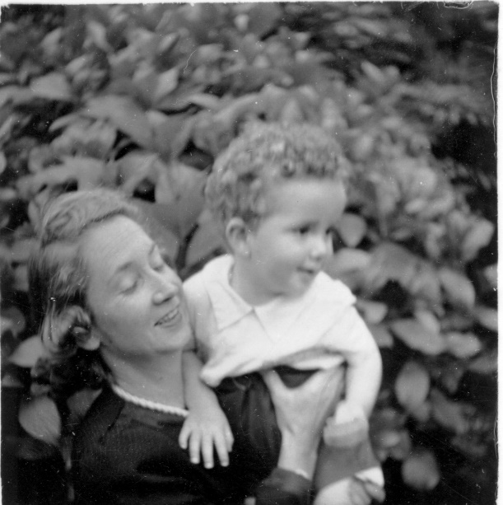 | 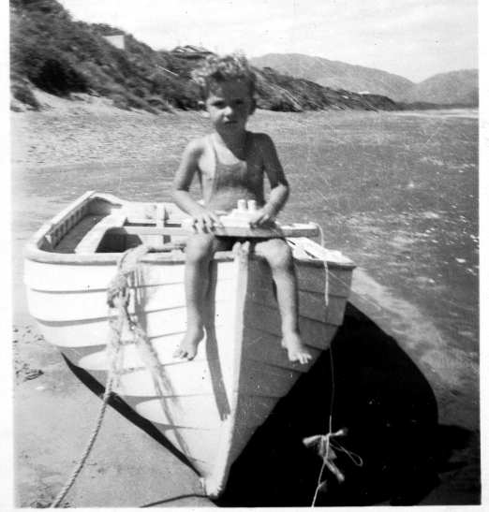
With Mother. Aged around 14 months | At a Kapiti Coast beach – aged 2 or 3

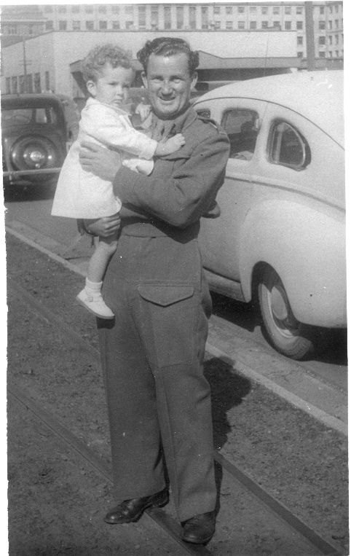 | 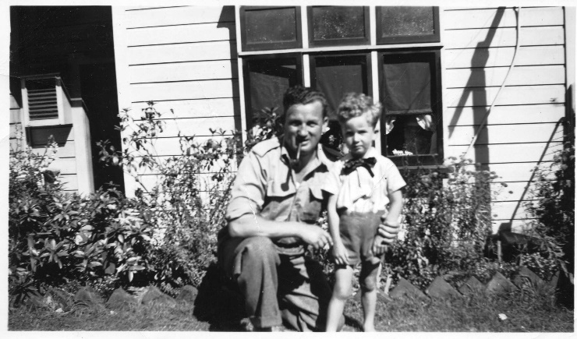
At a Wellington wharf with father just off troop ship. Aged around 18 months | Looking less wary of father. In garden at back of Tinakori Road Dairy. Aged around 3 years.

Wellington Tinakori Road Memories
Botanic gardens
I remember having an unbotanic interest in matters watery, such as the swans on the pond and in the shiny brown salt-glazed half round clay pipes laid as gutters, which still exist. Later this interest would re-emerge when I used the same pipes to make runnels and water features in a garden at Wembley Park London.

Circus
A Big Top – probably of Wirths’ Circus - was set up in Anderson park. I remember going into the Big Top with my granddad and, among other things, watching trapeze artists. Many years later I would know, and love, a trapeze artist.

Dick Seddon
I don’t recall it, but apparently I was interested to know just who was the man standing on top of the tall plinth in the Bolton Street Cemetery memorial park at the edge of Anderson Park. It was and is ‘King Dick’ Seddon, the popular Premier of New Zealand who died in 1906.

About Town

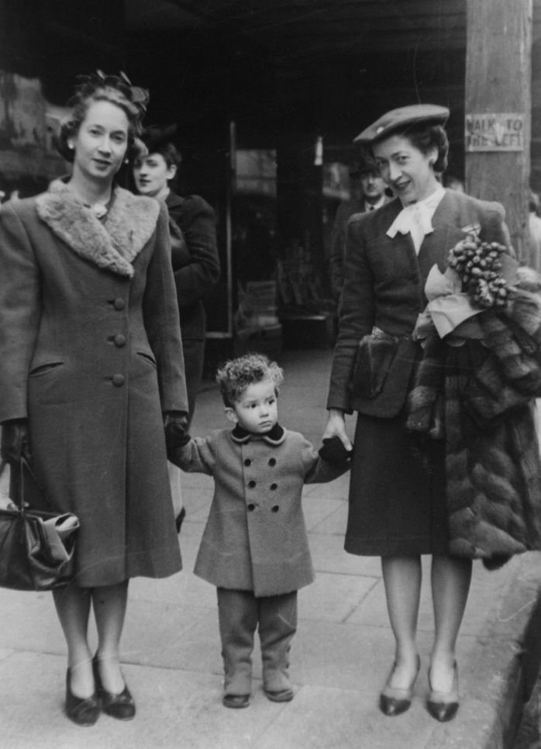 | Agnes (left) and Noreen and toddler Randall.  Around 1946. The photo is marked as being in Cuba street so the nearest department store was James Smith.

Like others of my generation I remember being taken into Department stores such as ‘The DIC’, ‘Kirks’ and James Smith. A street photo of me with Mum and favourite Aunt, Noreen, show us all amazingly accessorised including gloves against the non-Siberian cold of Wellington. Noreen is carrying a fur coat – just in case. I guess a well-behaved toddler was also an accessory in a big store where a highlight was to go up escalators and be seated in the tearoom. People made a fuss of you and produced exotic food items such as a ‘club sandwich’.

Purchases often centred on buying material for sewing and I recall being sat in high stools while bolts of cloth were laid out, chosen and cut. Most of the stores had a pneumatic tube system for putting money in a circular container and whooshing it off through the vacuum tubes to a central cashier. A short time later the cylinder would come clunking back into a basket to deliver the receipt and change. A triangular building in Newtown at the junction of Riddiford Road and Rintoul Street has an even earlier system where the container travelled along a wire to the cashier who was visible, but behind bars. A spring arrangement launched the container to whirr along the wire and, in turn, to be shot back to the shop desk.

It was an age where a 3-year-old hadn’t yet seen a motion picture, let alone a TV screen, so we took entertainment and absorbed knowledge from whatever we could.

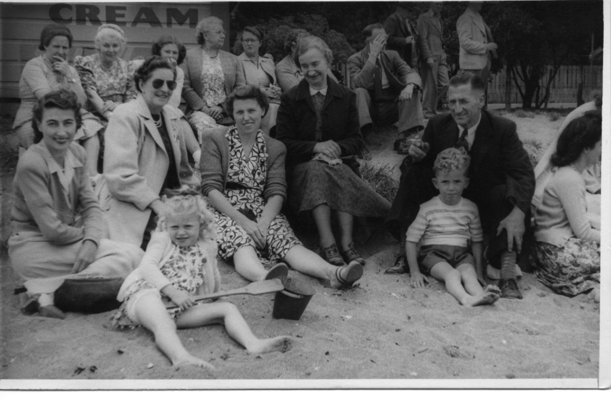
Days Bay, Wellington. Company Picnic of Levin and Company c1948. Randall sitting in front of grandfather Lou Randall. Family friend Eleanor Hackworth (‘Hackie’) sitting nearby in dark coat. We probably travelled by ferry across the harbour to The Domain at Days Bay.

